**DevOps Foundations: Version Control and CI/CD with Jenkins**

**Course-End Project : SlackUp Jenkins**

Objective

To create a Slack channel to receive Jenkins build notifications and use it to invoke Jenkins jobs remotely by configuring the slash commands in Slack

**Problem Statement and Motivation**

**Real-time scenario:** You are a DevOps Engineer at La' Marketthat recently adopted a microservices-based architecture for its flagship web application. Different development teams manage the respective functionalities of the application.

To improve the efficiency of deploying updates and manage releases, the company has decided to enable developers to trigger Jenkins jobs directly from their Slack channels once the build is completed and the team's channel is notified on Slack.

You are tasked with implementing Slack integration in Jenkins to remotely invoke Jenkins jobs from a Slack channel, facilitating automated deployment processes and enabling real-time updates and team collaboration.

**Industry Relevance**

The following tools used in this project serve specific purposes within the industry:

1. **Jenkins:** It is an open-source automation server commonly used in the software development industry for building, testing, and deploying projects. It supports continuous integration and continuous delivery (CI/CD) practices, enabling teams to increase efficiency, detect issues early, and accelerate software releases.
2. **Slack:**It is a widely-used collaboration tool that enhances communication and workflow efficiency across various industries by providing integrated chat, file sharing, and third-party app integrations.

**Business Impact**

**Jenkins:**

* 1. There is a 79% growth in Jenkins Pipeline usage from June 2021 to June 2023, reflecting an increase in CI/CD automation flows.
  2. Jenkins' overall CI/CD workload increased by 45% during the same period, highlighting its expanding role in software delivery.
  3. Jenkins’ growing adoption shows its effectiveness in improving software build and delivery processes across industries.

**Git and GitHub:**

* 1. Private repository contributions on GitHub grew by 38% in 2023, indicating increased adoption for internal and enterprise projects.
  2. Contributions to public open-source repositories on GitHub rose by 20%, highlighting the platform’s expanding role in fostering collaboration and innovation
  3. **Slack:**
  4. Development teams using Slack report delivering products 23% faster by streamlining workflows and enabling cross-functional collaboration, resulting in quicker releases and improved productivity.
  5. Slack has helped DevOps teams reduce testing and iteration time by 27%, allowing for faster identification and resolution of bug.

**Tasks**

The following tasks outline the process of integrating Slack with Jenkins and setting up a Slack channel to remotely trigger Jenkins jobs:

1. Create a Slack channel to get Jenkins build notifications
2. Configure Slack integration with the Jenkins plugin
3. Configure the post-build step to invoke Slack notification
4. Configure the slash command in Slack to invoke the Jenkins job

**Task 1 :** Create a Slack channel to get Jenkins build notifications

To archive this task we need login into slack, using this link [**https://app.slack.com/**](https://app.slack.com/),

Enter email id on the first page, then enter the confirmation code.

On the next page we going to create a Slack work space. (See below screenshots)

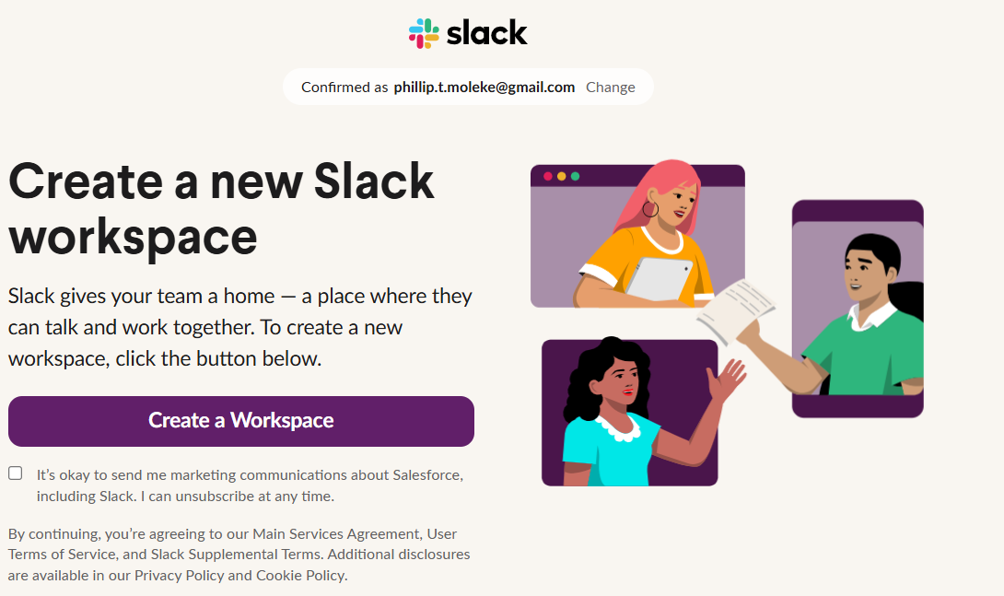

On the below screenshot we need to name the workspace then click next, next and skip on the last page.

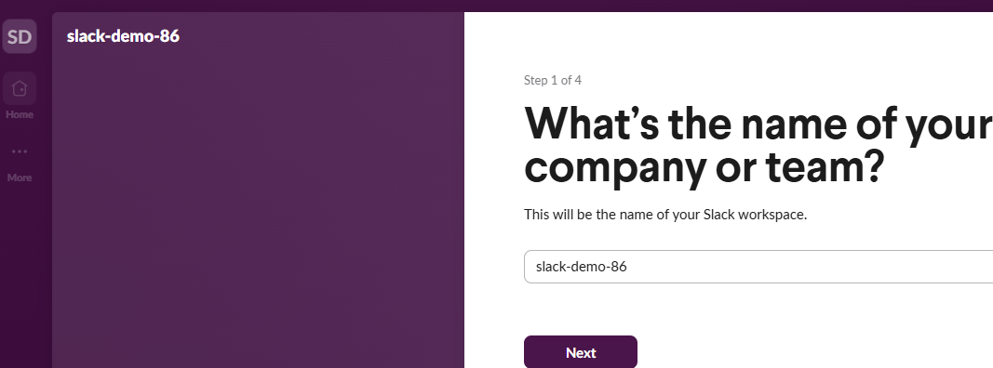

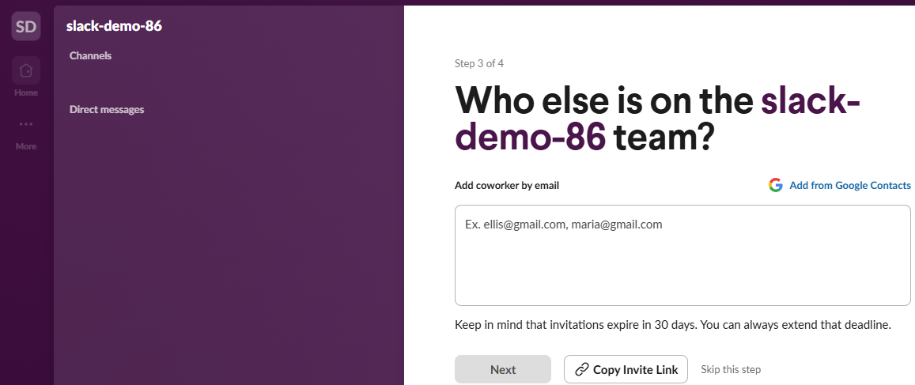

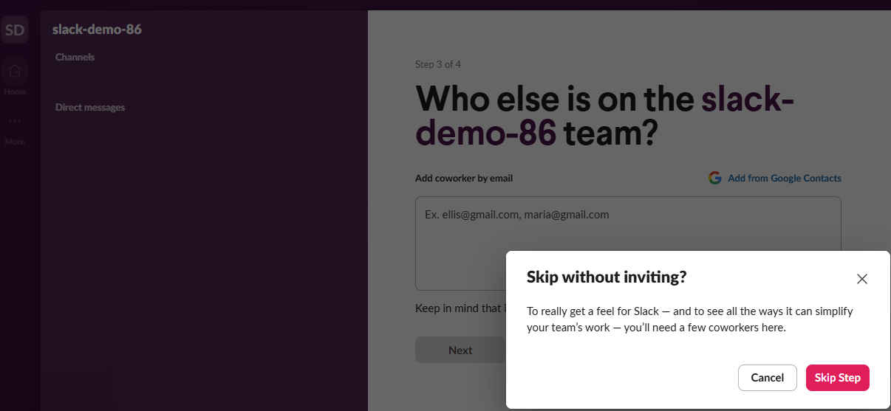

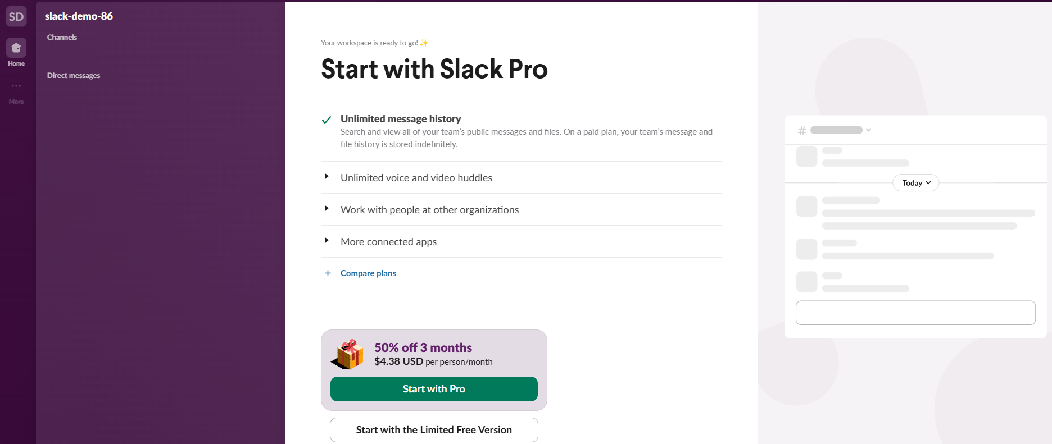

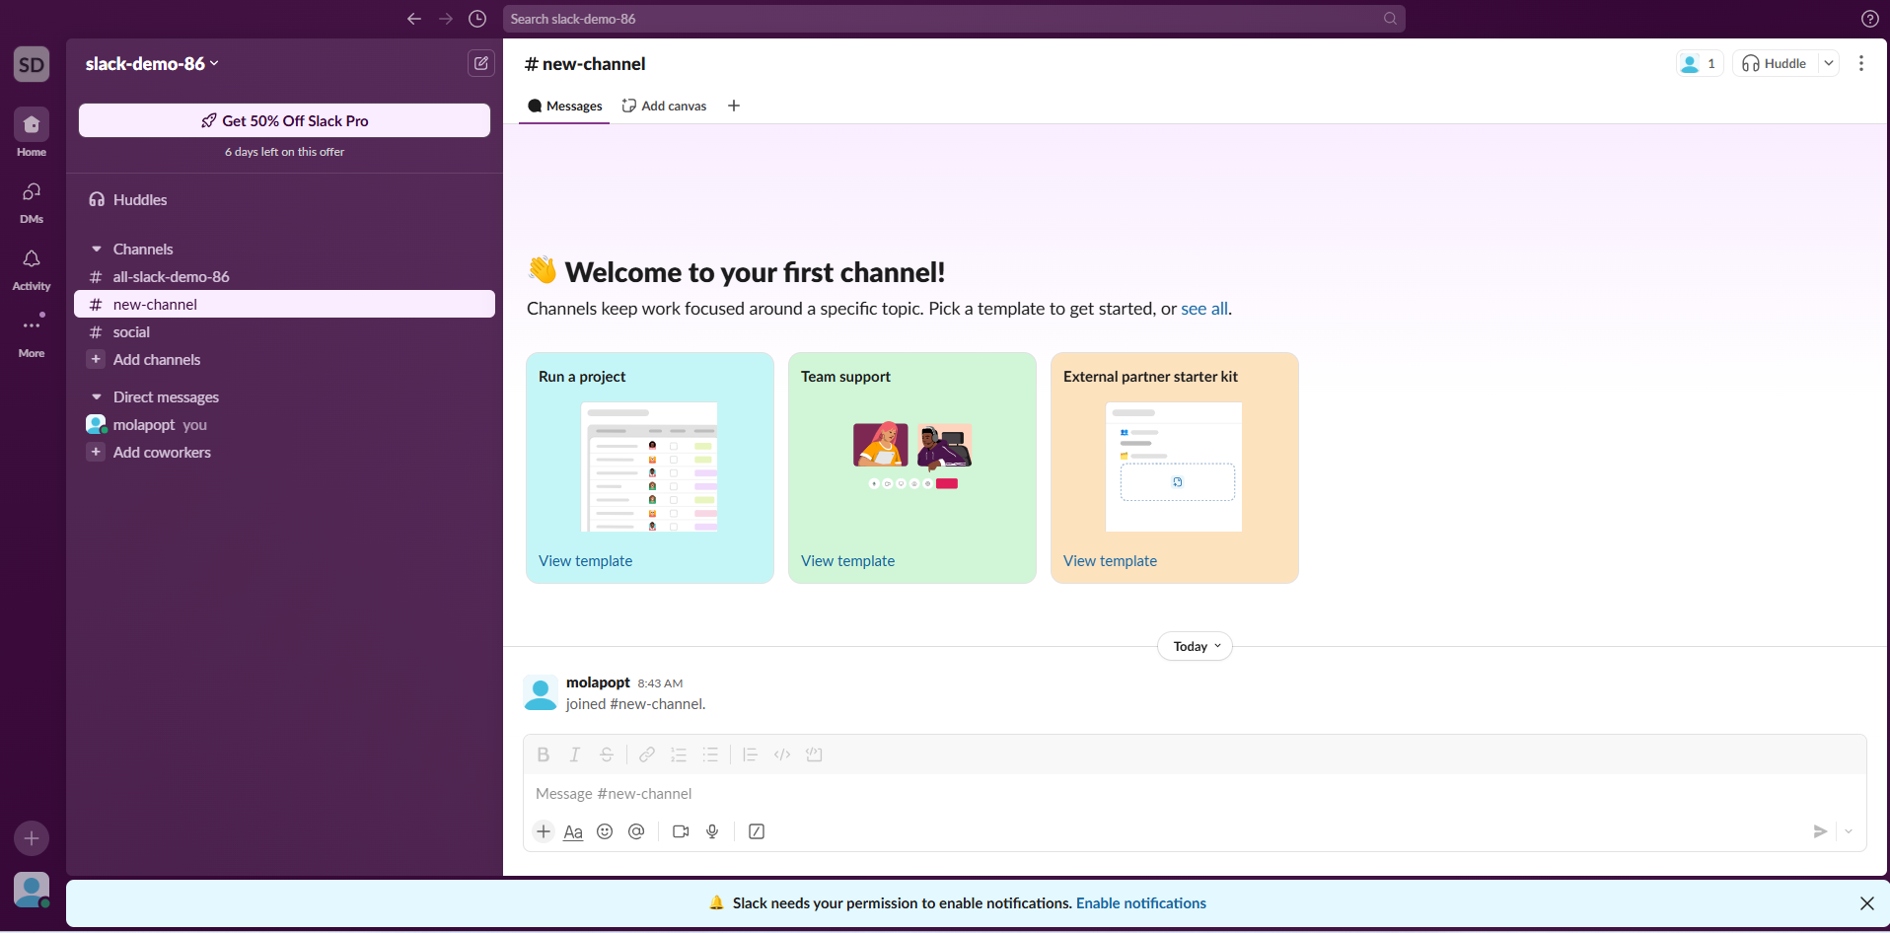

Then change #new-channel to the channel name ( in this case jenkinsnotifications )

Slack channel to obtain Jenkins build notifications

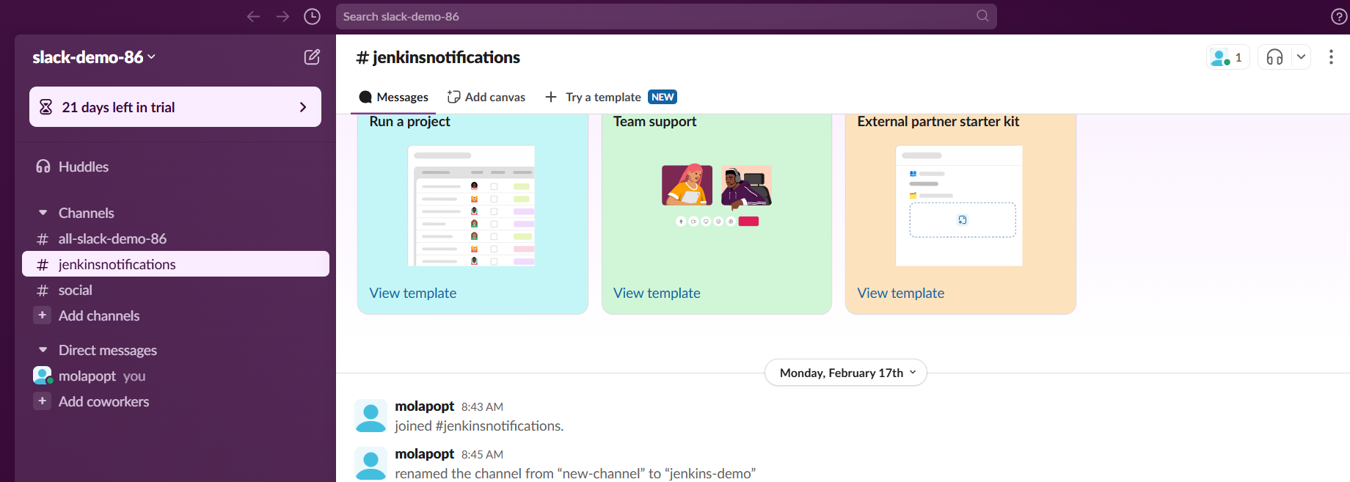

**Task 2:** Configure Slack integration with the Jenkins plugin

To integrate Slack with Jenkins, we need to add jenkins app to the newly created channel in task 1.

To archive this we need to click on the channel name, then click on integrations, then click on add an app, on the next page search for Jenkins, then install it. After the installation we need to click on Add to Slack, then select the channel name created in task 1, then click on add Jenkins Ci integration

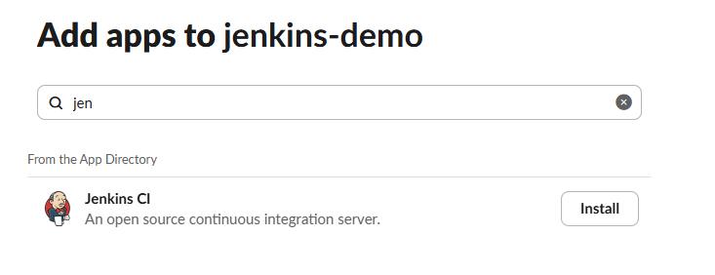

Slack Jenkins CI integration app to integrate Slack with Jenkins:

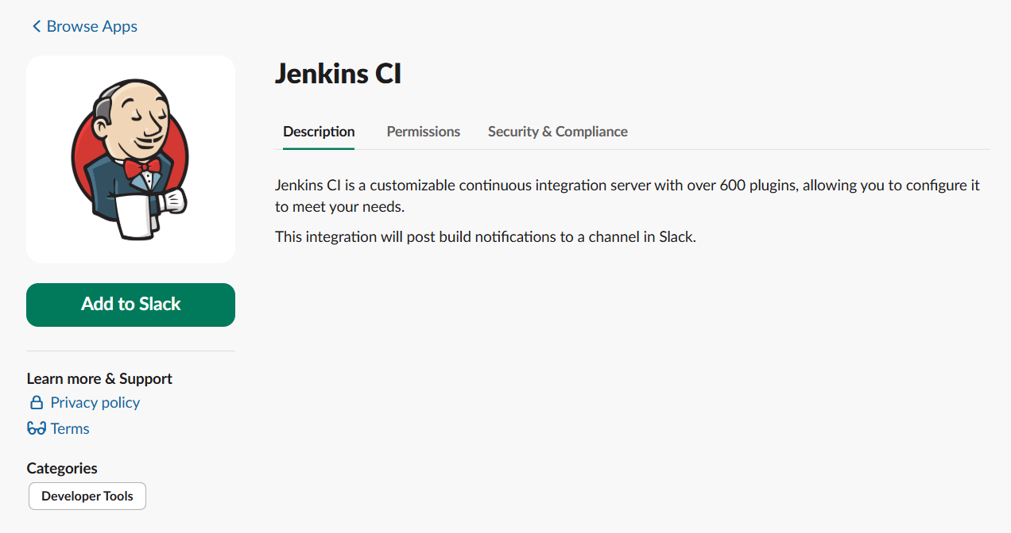

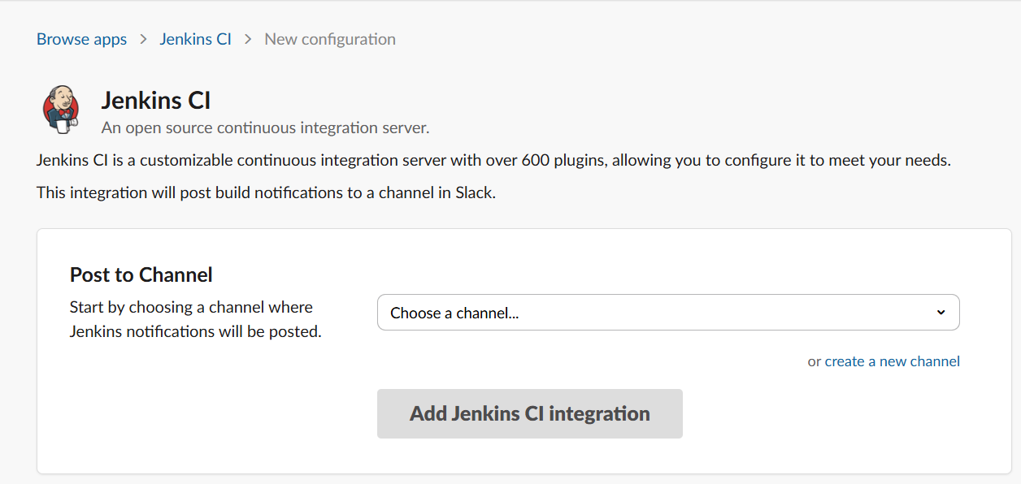

Take note of the of the team subdomain, and integration token Credential ID on the below screenshot

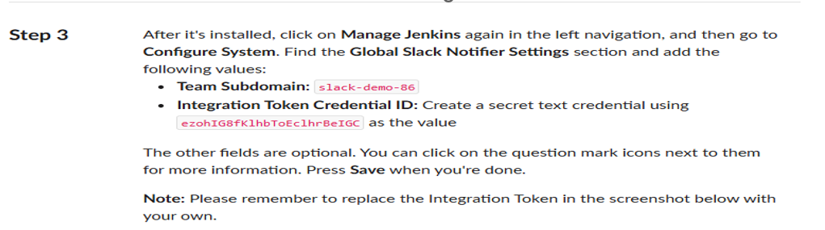

**Task 3:** Configure the post-build step to invoke Slack notification

To archive this task we need to install a Slack plugin in Jenkins and configure it as follows:

On Jenkins go to : Manage Jenkins – plugins – available plugins – search for Slack Notifications – then install.

Slack Notification plugin for Jenkins:

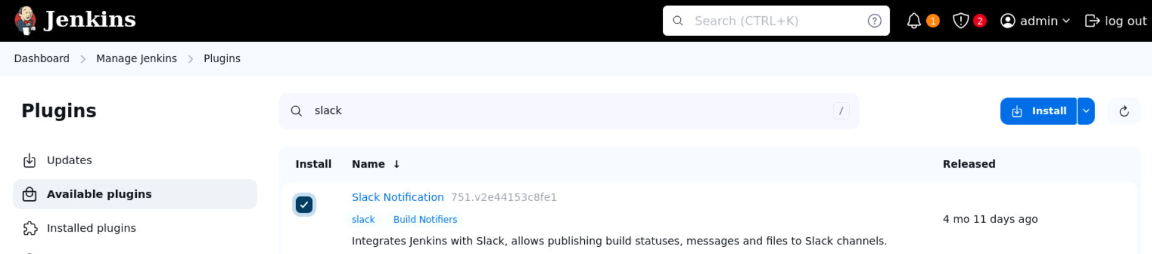

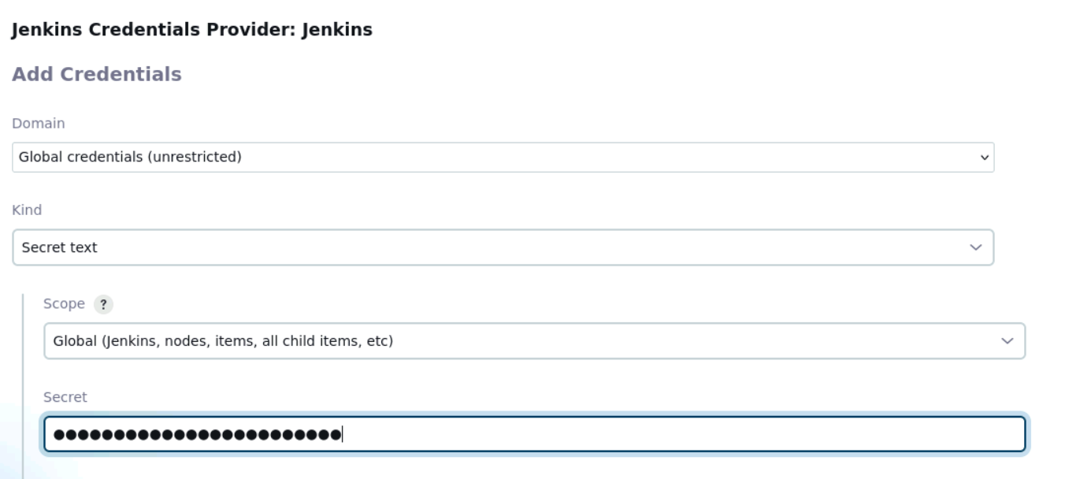

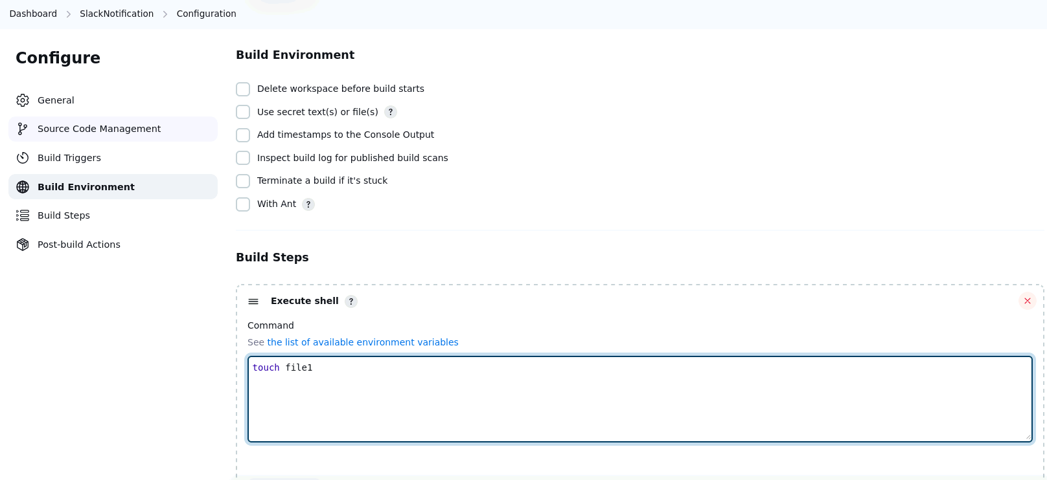

Slack notification configurations for Jenkins builds:

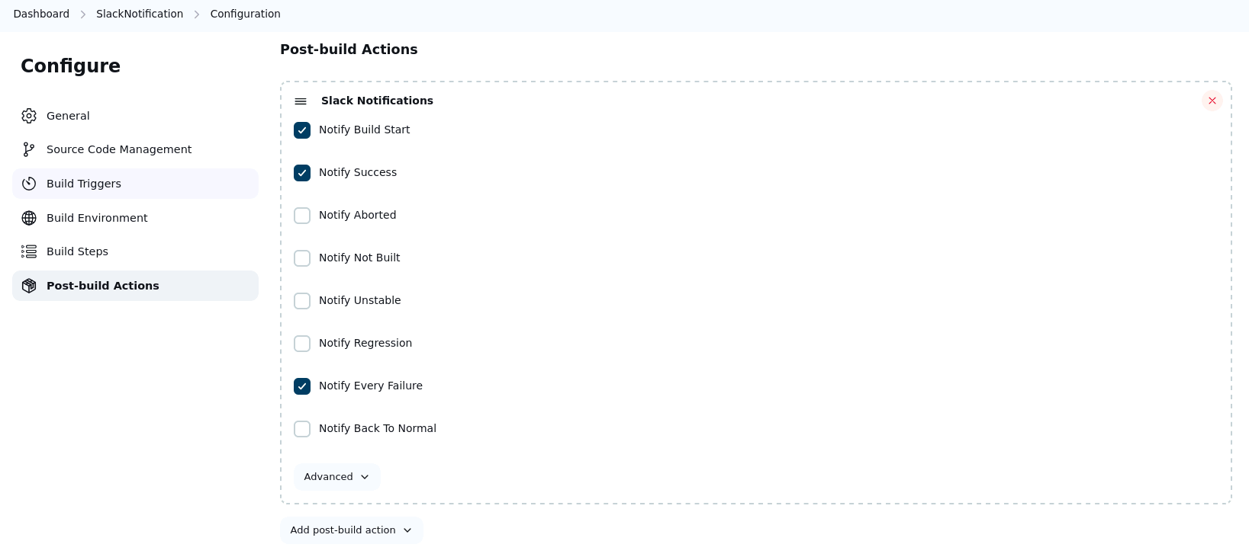

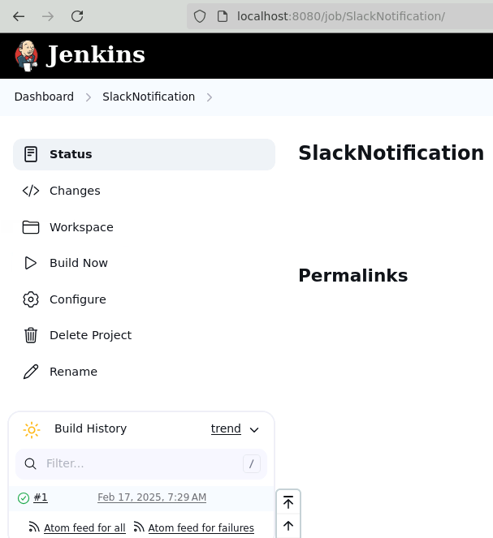

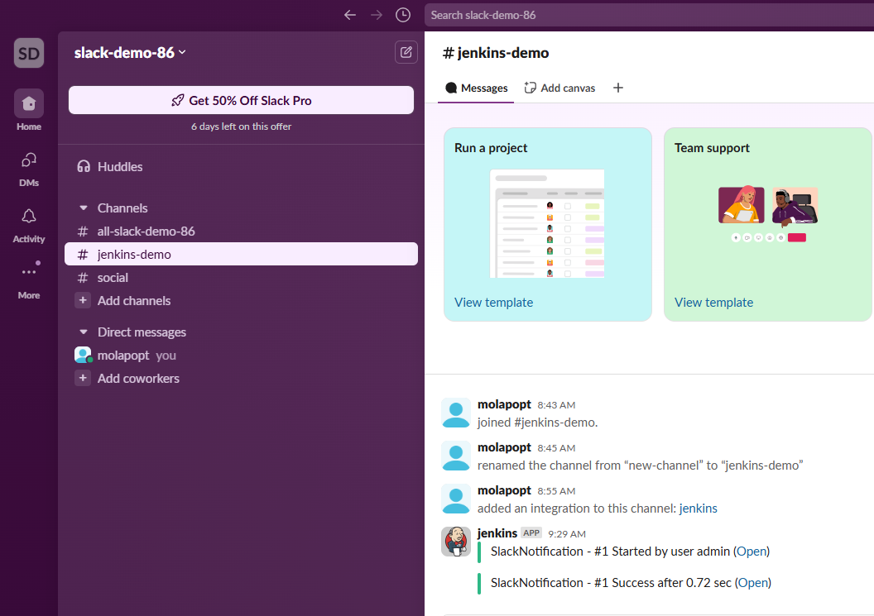

Pipeline job to be triggerd by Slack

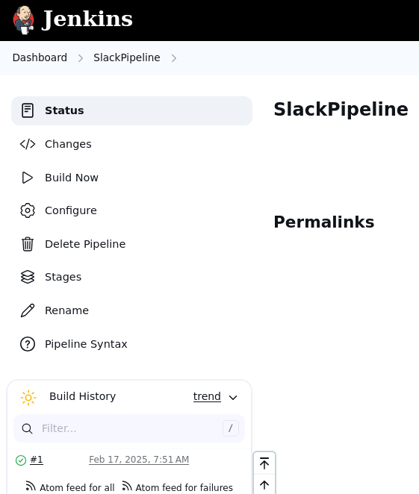

SlackPipeline Job code:

pipeline{

agent any

tools{

maven 'mymaven'

}

stages{

stage('Build Code'){

steps{

git 'https://github.com/Sonal0409/DevOpsCodeDemo.git'

sh 'mvn package'

}

post{

success{

slackSend channel: 'jenkinsnotification', message: 'Pipeline Job executed successfully'

}

failure{

slackSend channel: 'jenkinsnotification', message: 'Pipeline Job failed..'

}

}

}

}

}

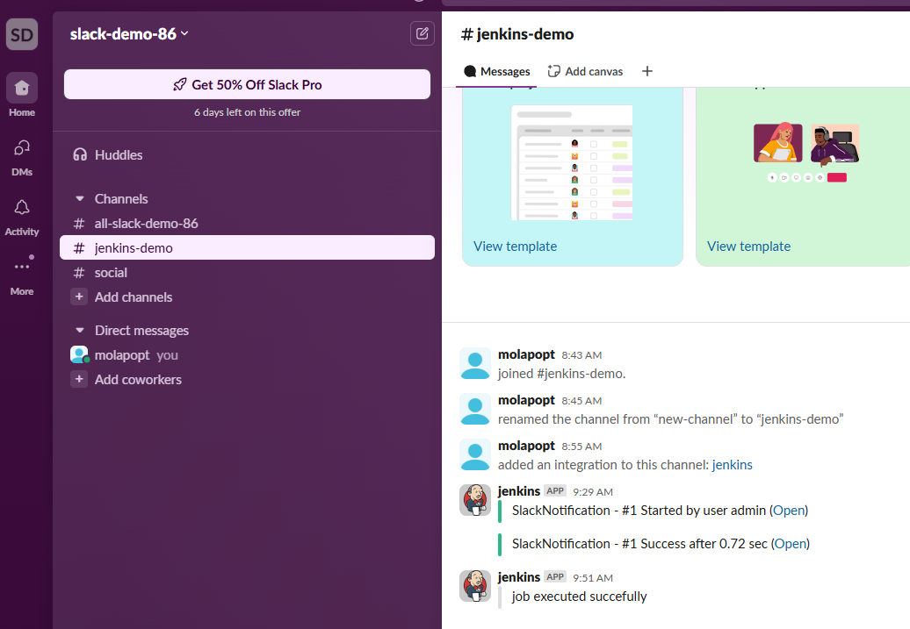

Task 4: Configure the slash command in Slack to invoke the Jenkins job

To archive this task we need to setup a trigger in Jenkins job so that it can be executed from slack or (remote server)

On the Jenkins job: click on configure – build triggers – and select the trigger “Trigger builds remotely (e.g, from script)”

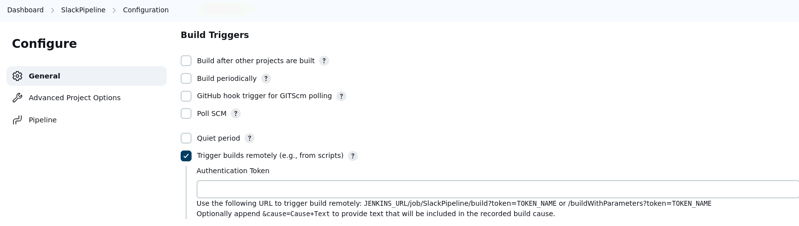

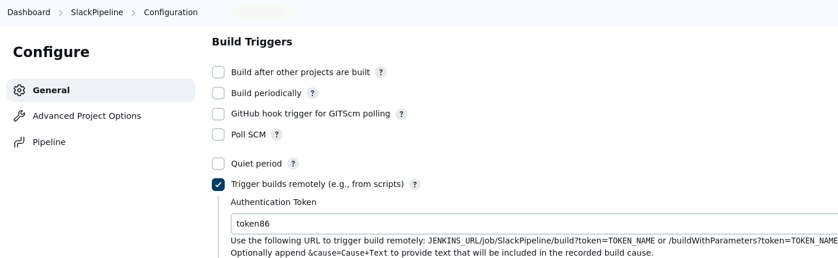

http://localhost:8080/job/SlackPipeline/build?token=token86

We also need to allow anonymous read access on Jenkins so Slack can be able to trigger / run the jobs in Jenkins remotely.

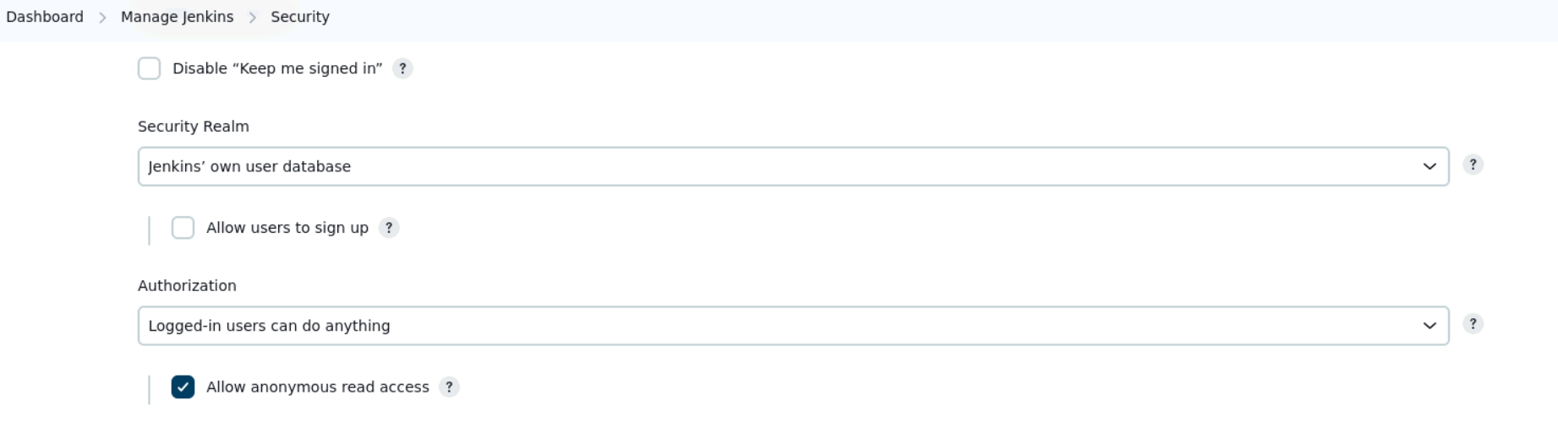

Now in Slack we need to add and configure an app that will allow Slack to run/trigger jobs in jenkins

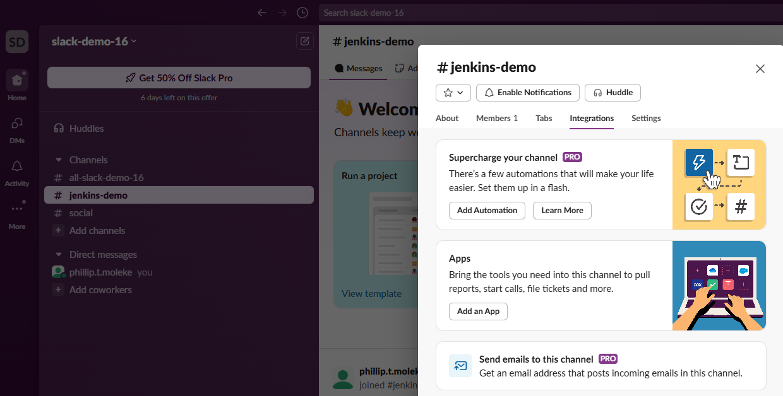

We will use Slash commands app

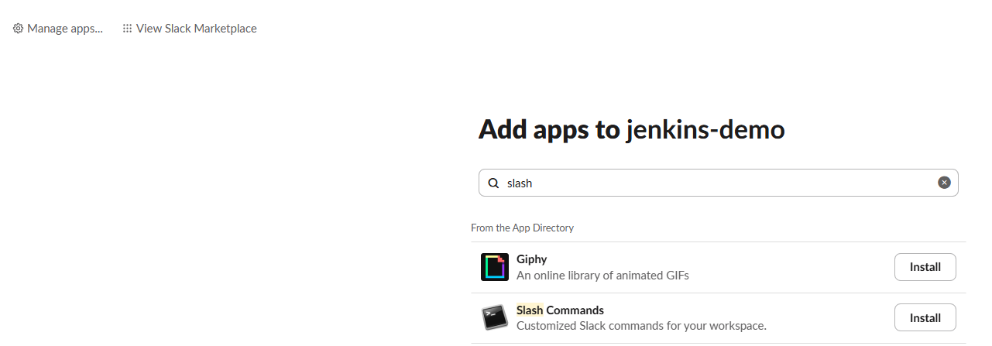

Slash commands integration with Slack:

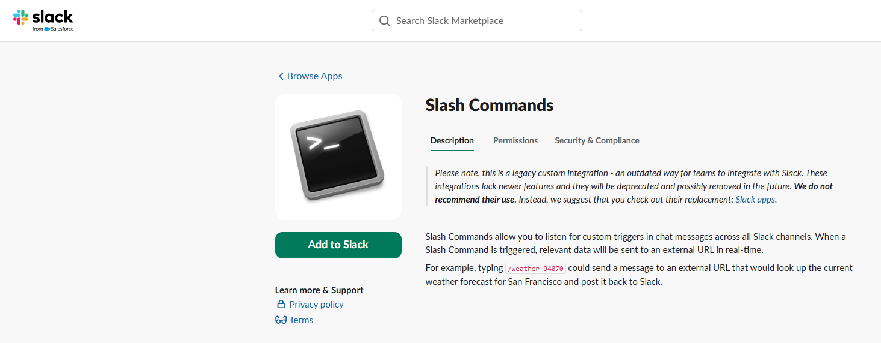

Slash commands customization to remotely trigger Jenkins jobs:

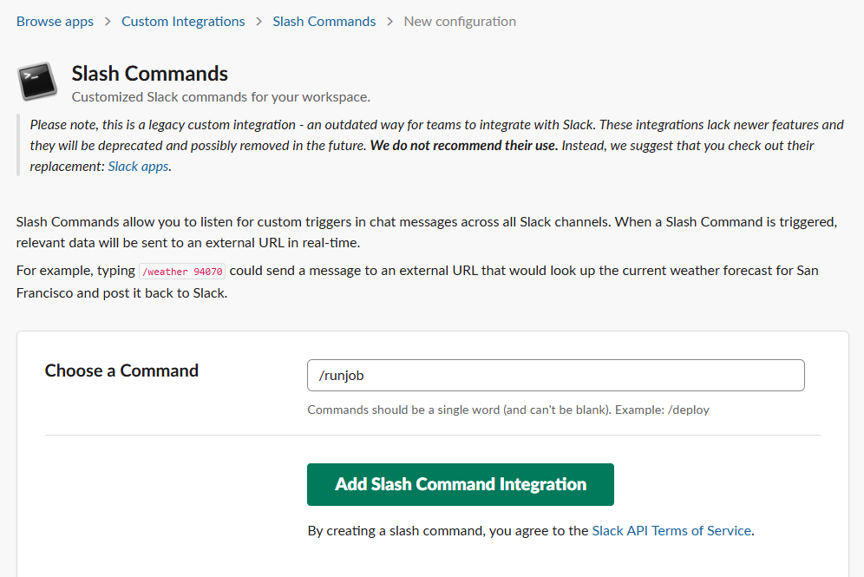

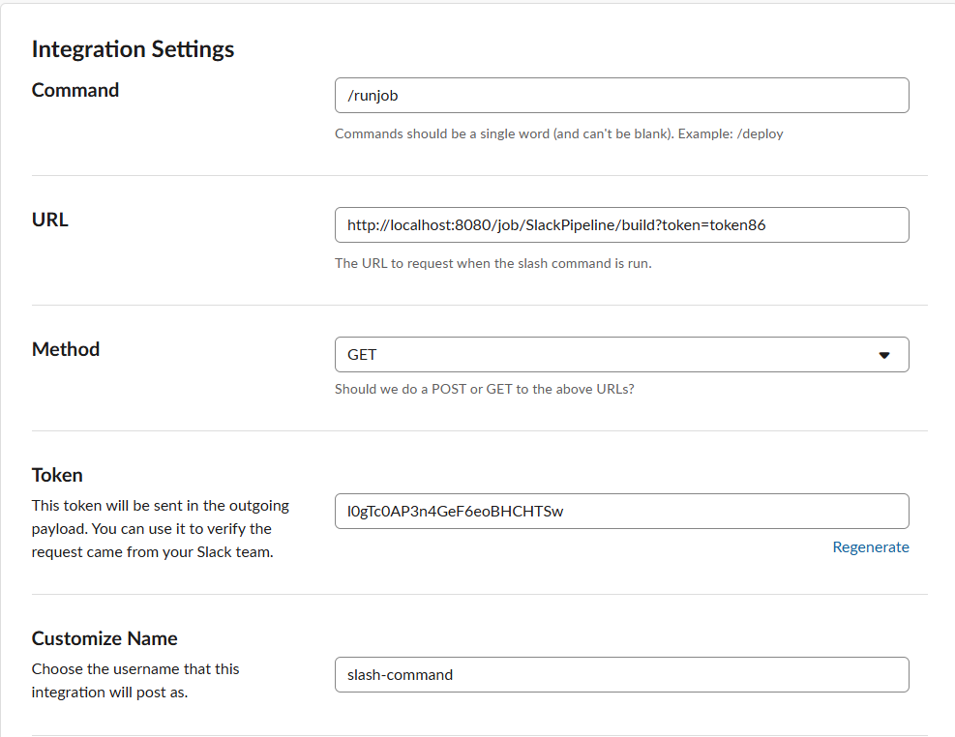

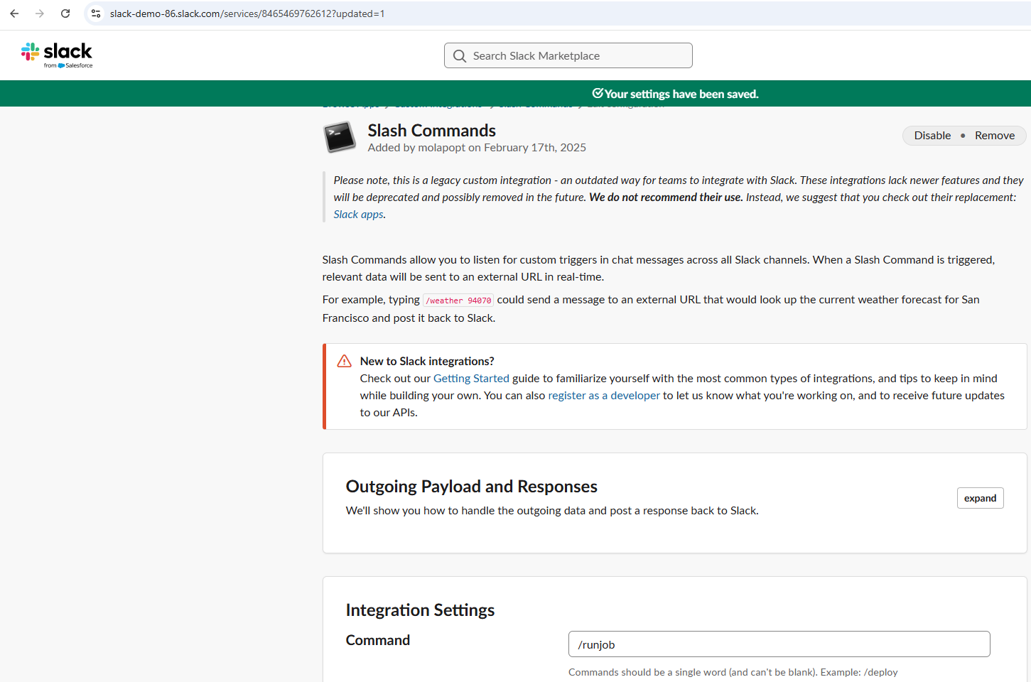

Remote Jenkins job triggering using the configured slash command:

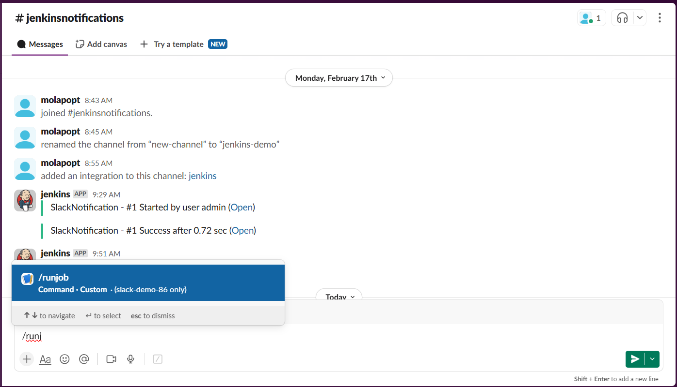

Done.

Thank you

Prepared by : Phillip Tshegofatso Moleke

Date: February 2025